Project Design Phase-II

**Data Flow Diagram & User Stories**

|  |  |
| --- | --- |
| Date | 15 October 2022 |
| Team ID | PNT2022TMID13036 |
| Project Name | Emerging methods for early detection of Forest Fire |

**Data Flow Diagrams:**

A Data Flow Diagram (DFD) is a traditional visual representation of the information flows within a system. A neat and clear DFD can depict the right amount of the system requirement graphically. It shows how data enters and leaves the system, what changes the information, and where data is stored.

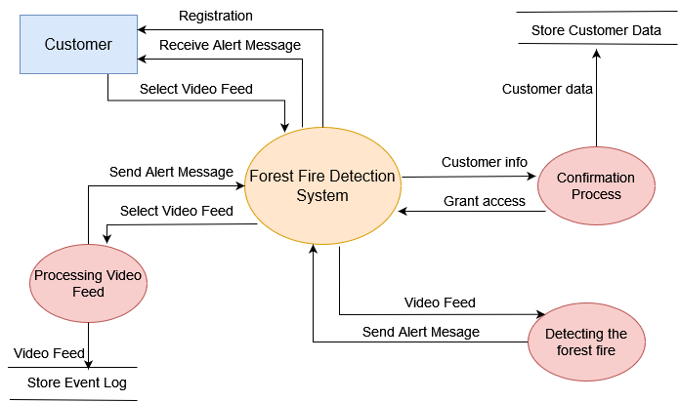

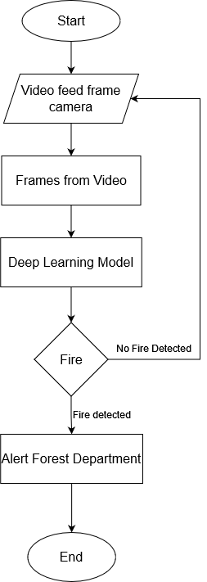**Flow Diagram:**

A flow diagram is a visualization of a sequence of actions, movements

within a system and/or decision points. They're a detailed explanation of

each step in a process, no matter the level of complexity of that process.

**User Stories**

| **User Type** | **Functional Requirement (Epic)** | **User Story Number** | **User Story / Task** | **Acceptance criteria** | **Priority** | **Release** |
| --- | --- | --- | --- | --- | --- | --- |
| Forest Department and Environmentalist | Registration | USN-1 | As a user, I can register for the application by entering correct my email, password, and confirming my password. | Only authorised government employees can be accepted | High | Sprint-1 |
|  |  | USN-2 | As a user, I will receive confirmation email once I have registered for the application. | I can receive confirmation email & click confirm | High | Sprint-1 |
|  | Login | USN-3 | As a user and a forest fire department staff, I will be provided with unique login ID and password. | I should enter correct email & password | High | Sprint-1 |
|  | IBM Cloud Server | USN-4 | The forest fire is detected using computer vision algorithm based cameras. These cameras continuously monitor the forest and the data is sent to the server. | I can receive the data | High | Sprint-2 |
|  |  | USN-5 | I can fetch the details/data from the cloud server. | I can access the data | High | Sprint-2 |
|  | Data Collection | USN-6 | I must gather information about forest fires. | I should collect the accurate data | High | Sprint-3 |
|  |  | USN-7 | I must draft and point out the algorithms to predict the forest fire. | I must analyse the algorithms with respect to its accuracy. | Medium | Sprint-3 |
|  | Algorithm Implementation | USN-8 | I must determine the precision of each algorithm. | I must calculate the accuracy of the algorithm | High | Sprint-4 |
|  |  | USN-9 | Extracting and assessing the Dataset | I must pre-process the dataset before training | High | Sprint-4 |
|  | Evaluating the Algorithm | USN-10 | I must determine the precision, recall and accuracy of the algorithm. | Accuracy is essential for detecting the presence of forest fire | High | Sprint-4 |